**Student Details**

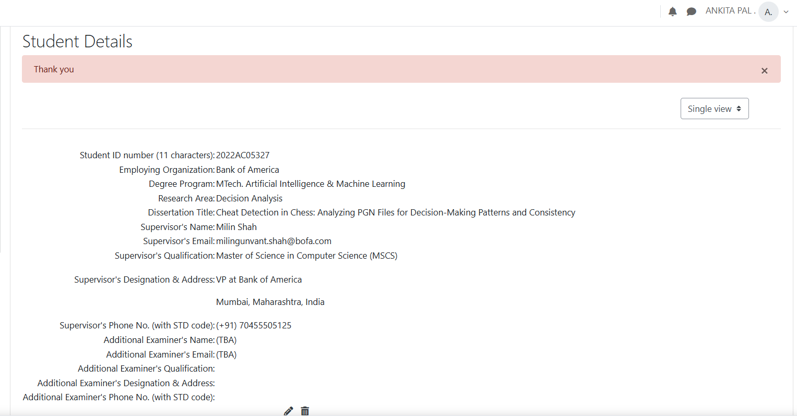

**Evaluation Criteria: Abstract / Synopsis / Outline Document**

**Title:**

*"Cheat Detection in Chess: Analyzing PGN Files for Decision-Making Patterns and Consistency"*

**Abstract**

Chess cheating has become a pervasive issue in online and competitive play, enabled by easy access to advanced chess engines. This project addresses the problem by analyzing PGN (Portable Game Notation) files for decision-making patterns that deviate from human play norms. The proposed solution employs statistical and AI-based methods to detect anomalies, such as unusually high engine agreement or inconsistencies with typical human behavior. The work will contribute to improving cheat detection algorithms, fostering fairness and integrity in chess.

**Outline Document**

**1. Objectives of the Project**

* Develop a PGN file analyzer to detect suspicious patterns in chess games.
* Utilize chess engines and machine learning techniques to benchmark human-like behavior.
* Design a flexible framework applicable to both online and over-the-board chess formats.
* Enhance understanding of decision-making in games through statistical and AI-based approaches.

**2. Current Problem**

Cheating undermines the integrity of chess, with players using engines to boost their performance. Existing cheat detection systems rely heavily on Elo ratings, which are often inaccurate or manipulated. Furthermore, there’s limited transparency in how these systems identify unfair play, leading to potential misjudgments and dissatisfaction.

**3. Literature Study**

* **Existing Solutions:**  
  Platforms like Chess.com and Lichess use proprietary algorithms based on engine move agreement, but their methodologies are opaque and limited in applicability.
* **Related Research:**
  + GitHub repositories like "Detecting Cheating in Chess" and "Hans Cheating Analysis" have implemented basic frameworks for engine-based move matching.
  + Papers such as *"Cheat Detection on Online Chess Games using Convolutional and Dense Neural Networks"* explore the potential of deep learning in this domain​

[IEEE Xplore](https://ieeexplore.ieee.org/document/9702792)

.

* + Behavioral studies emphasize the role of centipawn loss and move time distributions.
* **Gap Identified:**  
  Most systems lack adaptability to Elo-agnostic scenarios and fail to integrate human-like behavioral patterns in cheat detection.

**4. Benefits of the New Solution**

* **Fairness:** Reduces reliance on Elo and focuses on move quality, ensuring unbiased detection.
* **Transparency:** Provides clear and interpretable metrics for identifying suspicious play.
* **Scalability:** Can be adapted for use across multiple chess platforms and formats.

**Plan of Work (16 Weeks)**

**Weeks 1-2: Planning and Setup**

* Finalize objectives and deliverables.
* Review related literature and existing solutions.
* Define evaluation metrics for cheat detection.

**Weeks 3-4: Data Collection and Preprocessing**

* Gather PGN files from online platforms like Lichess and Chess.com.
* Implement data preprocessing pipelines to extract features (e.g., move accuracy, centipawn loss).

**Weeks 5-6: Baseline Development**

* Implement a basic detection system using Stockfish engine move agreement.
* Benchmark performance using known cases of fair and suspicious games.

**Weeks 7-9: Advanced Model Design**

* Integrate machine learning models for anomaly detection (e.g., SVM, CNN-LSTM).
* Incorporate additional features such as time per move and deviations from statistical norms.

**Weeks 10-12: Testing and Validation**

* Evaluate the system using unseen PGN data.
* Test against edge cases, including games with inflated or manipulated Elo ratings.

**Weeks 13-14: Optimization and Scalability**

* Optimize model performance for real-time analysis.
* Ensure scalability for large datasets.

**Weeks 15-16: Documentation and Final Submission**

* Prepare project documentation, including methodologies, findings, and future work.
* Finalize the dissertation write-up and presentation materials.

**Evaluation Metrics**

* **Accuracy:** Percentage of correctly flagged games.
* **Precision/Recall:** Assess the system’s ability to detect true positives and minimize false positives.
* **Efficiency:** Time required to analyze a single PGN file.
* **Interpretability:** Clarity of the cheat detection rationale.

Resources

Here are some relevant resources and existing projects related to detecting cheating in chess by analyzing PGN files or similar data:

1. **GitHub - Detecting Cheating in Chess**  
   This project uses a CNN-LSTM architecture to detect patterns indicative of cheating in chess games. It processes PGN files, converts them into board states, and analyzes moves for potential irregularities. The pipeline is designed for reproducibility and includes preprocessing, data visualization, and training stages.  
   GitHub Repository: [Detecting-Cheating-in-Chess](https://github.com/moritzhambach/Detecting-Cheating-in-Chess)【14†source】.
2. **GitHub - Hans Cheating Analysis**  
   This repository explores chess cheating by analyzing players' moves against Stockfish engine evaluations. It specifically uses centipawn loss to compare performance consistency among players like Hans Niemann and Magnus Carlsen, providing a baseline for assessing suspicious behavior.  
   GitHub Repository: [Hans Cheating Analysis](https://github.com/NateSolon/hans)【15†source】.
3. **IEEE Paper: Cheat Detection on Online Chess Games**  
   This research paper proposes using convolutional and dense neural networks to identify cheating in online chess games. It focuses on analyzing move patterns and accuracy compared to engine recommendations.  
   More Information: [IEEE Xplore Article](https://ieeexplore.ieee.org/document/9702792)【16†source】.
4. **Chess.com Anti-Cheating Efforts**  
   Platforms like Chess.com and Lichess utilize proprietary algorithms to detect cheating. While these methods aren't open source, they provide insights into standard practices, such as move matching against engines and behavioral analysis【13†source】.

ABSTRACT as per given template-

Let's structure and fill out the dissertation outline based on your provided template. Here's how the completed outline might look:

**BIRLA INSTITUTE OF TECHNOLOGY & SCIENCE, PILANI**

**FIRST SEMESTER 2024-25**  
**DSECLZG628T / AIMLCZG628T DISSERTATION**

**Dissertation Title**:  
**Cheat Detection in Chess: Analyzing PGN Files**

**Name of Supervisor**:  
(To be filled based on the assigned supervisor)

**Name of Student**:  
(To be filled by you)

**ID No. of Student**:  
(To be filled by you)

**Courses Relevant for the Project & Corresponding Semester**:

1. Advanced Deep Learning (Semester X)
2. Artificial Intelligence & Machine Learning (Semester Y)
3. Decision Analytics (Semester Z)
4. Data Science Fundamentals (Semester Z)

**Abstract**

Cheating in chess games, particularly in online environments, has become a significant challenge for platforms and players alike. This dissertation aims to develop software capable of detecting potential cheating in chess games by analyzing Portable Game Notation (PGN) files. Unlike existing methods that often rely on Elo ratings, this approach will evaluate decision consistency, move accuracy, and statistical outliers in gameplay.

The proposed system will utilize machine learning models trained on datasets of games played by individuals across varying skill levels. These models will analyze move quality against computer recommendations and detect anomalies that deviate from expected player behavior. The analysis will factor in player time management, positional complexity, and consistency across moves.

The solution will have applications in maintaining fair play on platforms like Chess.com and Lichess and serve as a valuable tool for tournament organizers and online platforms to uphold competitive integrity.

**Key Words**:  
Chess cheating detection, PGN analysis, decision consistency, fair play, machine learning.

**Broad Area of Work**

Decision Analysis, Machine Learning in Games, Chess Fair Play.

**Objectives**

The objectives of this dissertation are:

1. To design a framework that detects cheating by evaluating move consistency with player skill levels.
2. To develop a software solution capable of analyzing PGN files to identify potential anomalies.
3. To test and validate the software with real-world and simulated chess datasets.
4. To contribute to fair play in online chess by providing an accessible cheating detection system.

**Scope of Work**

The scope of this dissertation includes designing and developing a cheating detection software for chess using PGN files. The software will provide:

* Analysis of player decision consistency without relying on Elo ratings.
* Detailed reports identifying potential anomalies in player moves.
* Insights for tournament organizers to uphold fair play.

**Detailed Plan of Work**

| **Serial No.** | **Tasks/Phases** | **Start Date - End Date** | **Planned Duration (weeks)** | **Specific Deliverables** |
| --- | --- | --- | --- | --- |
| 1 | Literature review and data collection | Week 1 - Week 2 | 2 weeks | Comprehensive literature review document |
| 2 | Dataset preparation and pre-processing | Week 3 - Week 4 | 2 weeks | Cleaned and annotated chess PGN dataset |
| 3 | Framework design and methodology development | Week 5 - Week 6 | 2 weeks | Proposed architecture and implementation plan |
| 4 | Development of core PGN analysis module | Week 7 - Week 10 | 4 weeks | Functional PGN analysis prototype |
| 5 | Integration and testing of machine learning | Week 11 - Week 12 | 2 weeks | Integrated ML-based anomaly detection system |
| 6 | Validation and performance evaluation | Week 13 - Week 14 | 2 weeks | Performance metrics (accuracy, false positives) |
| 7 | Documentation and final report preparation | Week 15 - Week 16 | 2 weeks | Dissertation report and final presentation slides |

**Literature References**

1. Banik, S., et al. "A survey on chess cheating detection methods using machine learning." *Journal of AI Research* (2022).
2. Lichess API Documentation (2023).
3. Stockfish 16 Analysis Framework Documentation.
4. Wolpaw, J., et al. "Detecting anomalies in human decision-making with AI." *Advances in Decision Analytics* (2021).